

December 4, 2024

A Note from Tony Hagood

**Hello HUMC Friends,**

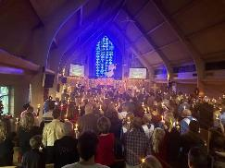

As the holidays quickly approach, I find myself both excited and, honestly, a little stressed! The holiday season is busy for many of us, and for musicians, it’s often the busiest time of the year. I wanted to give you a glimpse into the life of a working musician during this season — perhaps some of these experiences will resonate with you.

The past few years have been record-breaking for me in various ways. While I may not have more performances booked this year compared to last (hard to beat 50+ in 2023 😊!), the level of the performances has significantly increased. This brings not only joy but also added preparation and a bit of stress.

This weekend, I’ll be performing with the Columbus Symphony Orchestra for their Holiday Pops concert for the second year in a row, and it’s shaping up to be one of my favorite holiday concerts yet!

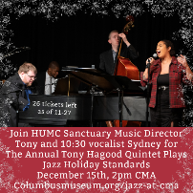After the Sunday matinee, I’ll head to Natalie’s for a sold-out performance of Vince Guaraldi’s music. On Sunday, December 15th at 2pm, I’ll present my 4th annual Holiday Jazz Concert at the Columbus Museum of Art, where only 20 tickets remain as of the writing of this letter. (https://www.columbusmuseum.org/calendar-and-events/jazz-at-cma/)

Later this month, I’ll close the year with the New Albany Symphony Orchestra’s Holiday Spectacular, Christmas Eve services at HUMC (1pm and 11pm) (https://hilliardumc.org/events/christmas-eve-worship-2/), and my final Ginger Rabbit performance on the 27th.

Despite the demanding schedule, I find solace in routines that ground me — and many of those involve HUMC. From choir rehearsals on Wednesday evenings to Sunday morning services (even as someone who is not an early riser!), these moments bring me comfort. But most of all, spending time with my HUMC family — whether chatting before or after services, grabbing a coffee, or sharing music together — brings me immense joy.

People often ask, “How do you do it?” and follow up with, “Why?” The full answer is complex, but **what I know for sure is this: I love sharing the gift of music.** **It’s a way to connect, to uplift, and to bring beauty into the world.**

One of the greatest joys of working at HUMC is hearing your voices join ours during worship. Some Sundays, the congregation sings louder than we do, and I love it! Thank you for being the church and giving back the music we share.

Through my years in music — whether performing, working as a staff pianist, teaching lessons and an occasional class at Otterbein University, or learning from others — I’ve encountered inspiring philosophies. One that resonates deeply with me is that while musicians, artists, and dancers may not be valued by society in the same way society values doctors or firefighters who physically save lives, we connect with people in ways others cannot. Through music, we provide comfort, clarity, and joy. Whether performing for hundreds or just a few, if I can change a life through music, I know I’ve made the world a little better, and maybe that’s just what the world needs.

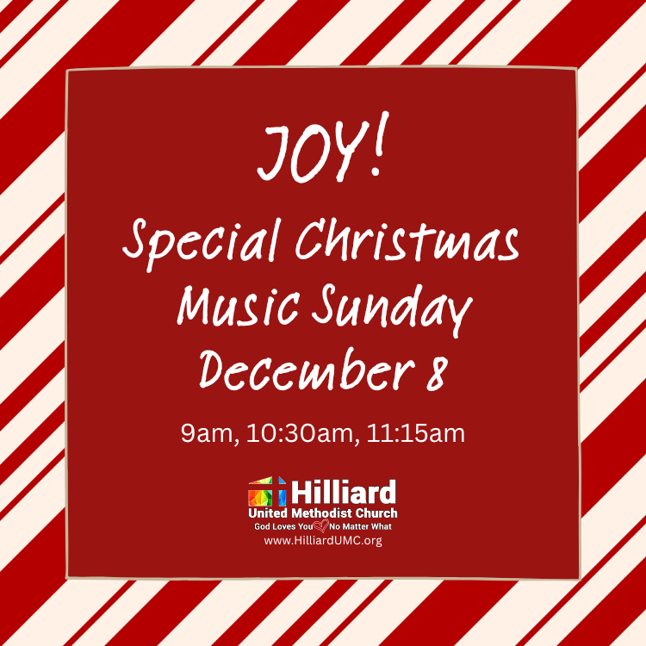**We have some wonderful music planned for you this Advent season!** I hope you’ll join us for Joy! Special Music Sunday this weekend, December 8 (https://hilliardumc.org/events/christmas-music-sunday/) at all three services, and for each Sunday in December. Christmas Eve will be particularly special as well, and I can’t wait to share those moments with you. (https://hilliardumc.org/events/christmas-eve-worship-2/)

Thank you for welcoming me into the HUMC family over the past year and a half. I hope the music we create together carries you into the new year and connects with you in meaningful ways, and I hope even more of you will join us in the choir, singing a song, or playing an instrument for 2025!

With gratitude,

Tony

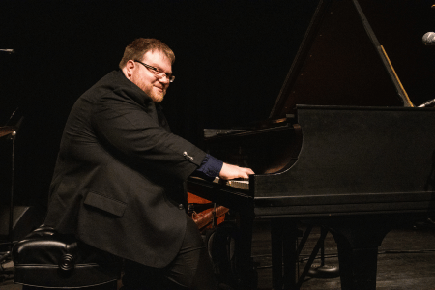

Tony Hagood, BM

Sanctuary Music Director

tony@hilliardumc.org

www.tonyhagood.com

https://hilliardumc.org/people/tony-hagood/

